PAPER 2

SECTION A

SENTENCE CONSTRUCTION

SUGGESTED WORD LIST

TENSES : Fill in the past tense vebs.

Present tense | Past tense | Present tense | Past tense
answer |  | call
arrange |  | carry
assemble |  | choose
eat |  | clap
bake |  | clean
bargain |  | clear
bathe |  | cook
blow |  | cross
borrow |  | cry
boil |  | catch
brush |  | cheer
bring |  | clap
buy |  | collect
build |  | cook
come |  | cut
cycle |  | join
drink |  | jump
drive |  | kick
drop |  | learn
enjoy |  | like
explore |  | listen
fall |  | make
feed |  | meet
feel |  | open
fly |  | plan
frighten |  | play
get |  | practise
give |  | speak
go |  | talk
hear |  | tell
help |  | teach
hide |  | wear
hit |  | write

SUBSTITUTION TABLE

TABLE 1 : Present Tense

He  She  It | goes  brushes  eats | to school.  the floor.  some fish.
I  You  They  We | go  brush  eat | to school.  the floor  some fish.

TABLE 2 : Present Continuous Tense

He  She  It | is | going to school.  brushing the floor.  eating the fish.
I | am | going to school.  brushing the floor.  eating the fish.
You  They  We | are | going to school.  brushing the floor.  eating the fish.

TABLE 3 : Past Tense

He  She  It | went  brushed  ate | to school.  the floor.  some fish.
I  You  They  We | went  brushed  ate | to school.  the floor  some fish.

TABLE 2 : Present Continuous Tense

He  She  It  I | was | going to school.  brushing the floor.  eating the fish.
You  They  We | were | going to school.  brushing the floor.  eating the fish.

TITLE : FISHING
Look at the pictures carefully and write down the nouns and verbs related to the pictures.
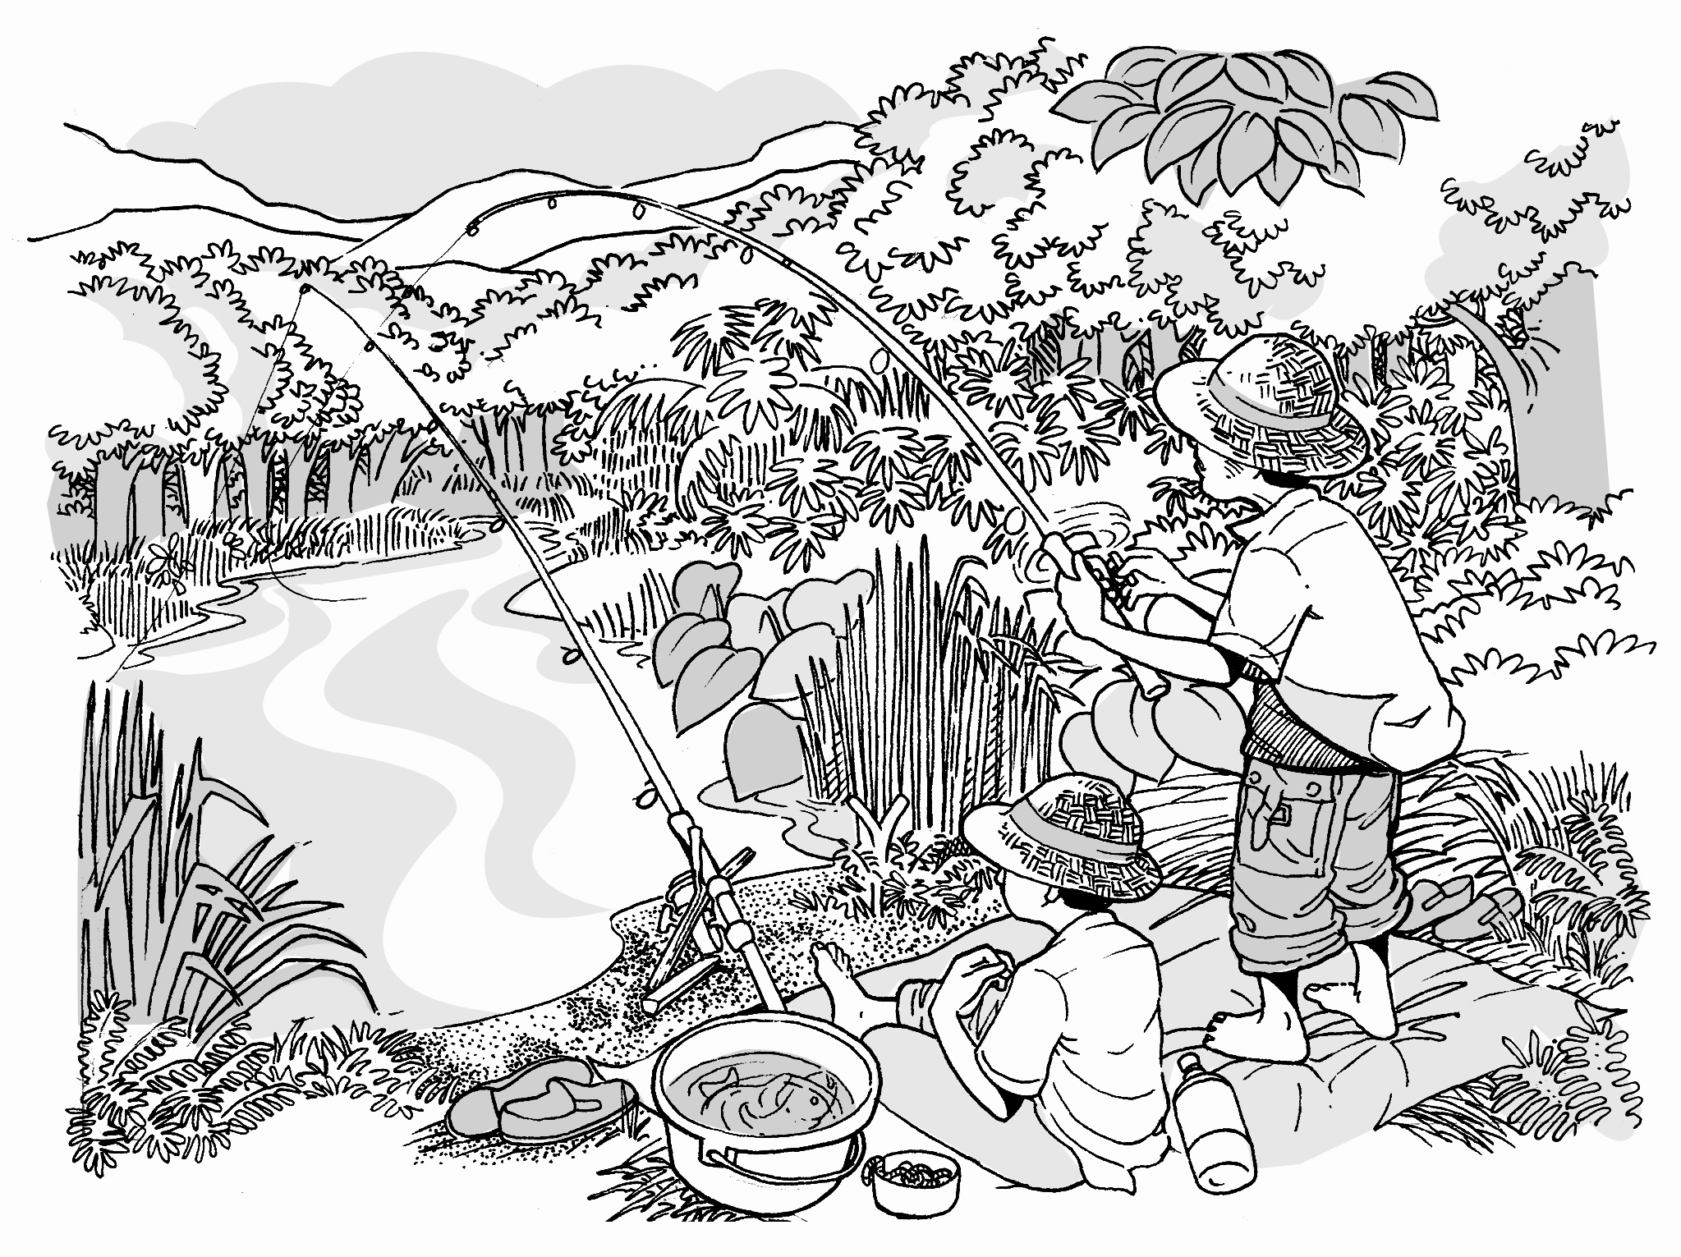

4

3

5

1
2

man | son | fishing | hot | fishing rod
wearing | hats | bucket | river | fish

Subject /  Nouns | Verbs /  Verb-to-be | Story
man and son | are | river
weather | is | hot
they | bring | fishing rod
they | are | hats
there | are | fish

Join the words to construct sentences grammatically correct.

- __________________________________________________

__________________________________________________

- __________________________________________________

__________________________________________________

- __________________________________________________

__________________________________________________

- __________________________________________________

__________________________________________________

- __________________________________________________

__________________________________________________

ENRICHMENT ACTIVITY:
Add other words to contruct compound sentences:

- – not far – their house
- – sit – big - shady tree
- – baits – catch - fish
- – sit - mat
- – big fish - buckets

Rewrite the sentences:

1. ____________________________________________________

____________________________________________________

2. ____________________________________________________

____________________________________________________

3. ____________________________________________________

____________________________________________________

4. ____________________________________________________

____________________________________________________

5. ____________________________________________________

______________________________________________________

TITLE : GOTONG-ROYONG
Look at the pictures carefully and write down the nouns and verbs related to th pictures.
2
3
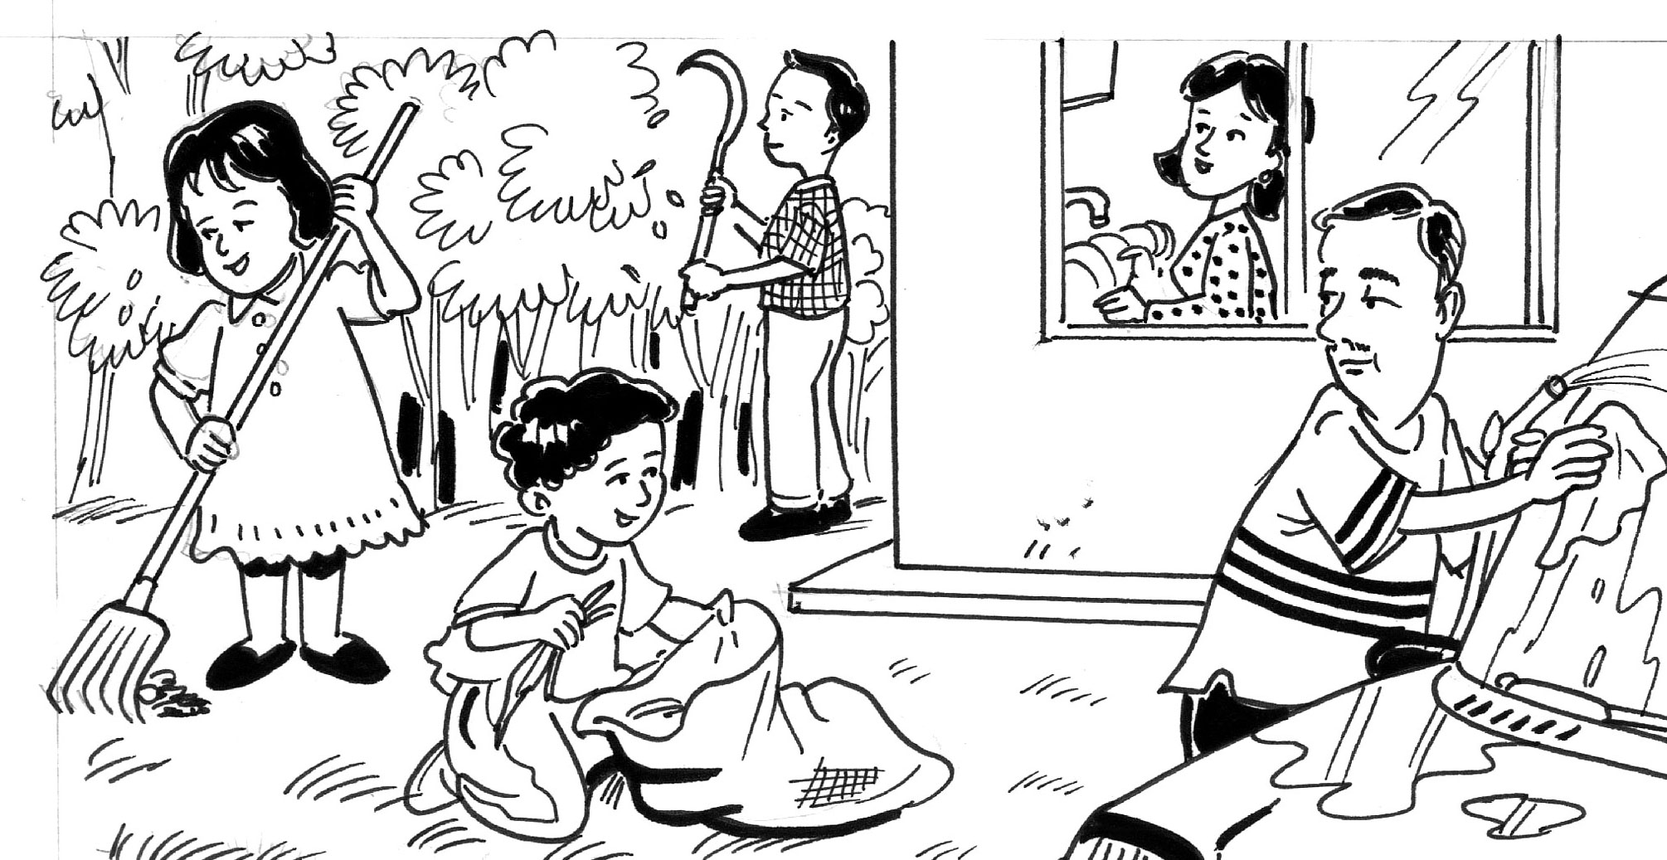
5

1

4

wash | car | clean | plates | trim
tree | collect | rake | dried leaves | compound

Subject /  Nouns | Verbs /  Verb-to-be | Story
father | wash | car
mother | clean | plates
brother | trim | tree
youngest son | collect | dried leaves
sister | rake | dried leaves

Join the words to construct sentences grammatically correct.

- __________________________________________________

__________________________________________________

- __________________________________________________

__________________________________________________

- __________________________________________________

__________________________________________________

- __________________________________________________

__________________________________________________

- __________________________________________________

__________________________________________________

ENRICHMENT ACTIVITY:
Add other words to contruct compound sentences:

- - new car – himself– in front of the house
- - carefully – in the big and spacious kitchen
- - with a sickle - beside the house
- - put – the big plastic bag
- – at the house compound

Rewrite the sentences:

1. ____________________________________________________

____________________________________________________

2. ____________________________________________________

____________________________________________________

3. ____________________________________________________

____________________________________________________

4. ____________________________________________________

____________________________________________________

5. ____________________________________________________

____________________________________________________

TITLE : BIRTHDAY PARTY
Look at the pictures carefully and write down the nouns and verbs related to the pictures.

4
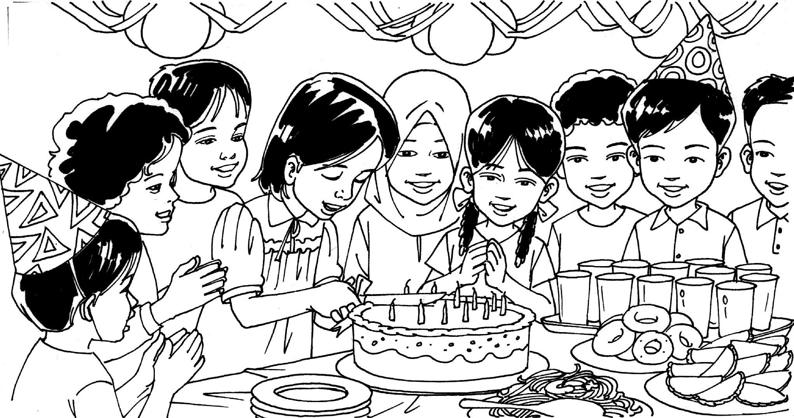
3
2
5
1

Salmah’s | birthday | cut | cake | friends
clap | many | balloons | ribbons | food

Subject/  Nouns | Verbs /  Verb-to-be | Story
today | is | Salmah’s birthday
she | cut | the birthday cake
friends | clap | their hands
there | are | balloons and ribbons
the food | is | delicious

Join the words to construct sentences grammatically correct.

- __________________________________________________

__________________________________________________

- __________________________________________________

__________________________________________________

- __________________________________________________

__________________________________________________

- __________________________________________________

__________________________________________________

- __________________________________________________

__________________________________________________

ENRICHMENT ACTIVITY:
Add other words to construct compound sentences:
- – celebrate - her friends
- – sharp knife – give to her friends
- – sing birthday song – happily
- – use – decorate – house
- –prepared – mother – on the table

Rewrite the sentences:

1. ____________________________________________________

____________________________________________________

2. ____________________________________________________

____________________________________________________

3. ____________________________________________________

____________________________________________________

4. ____________________________________________________

____________________________________________________

5. ____________________________________________________

____________________________________________________

TITLE : AT THE PLAYGROUND
Look at the pictures carefully and write down the nouns and verbs related to the pictures.
5

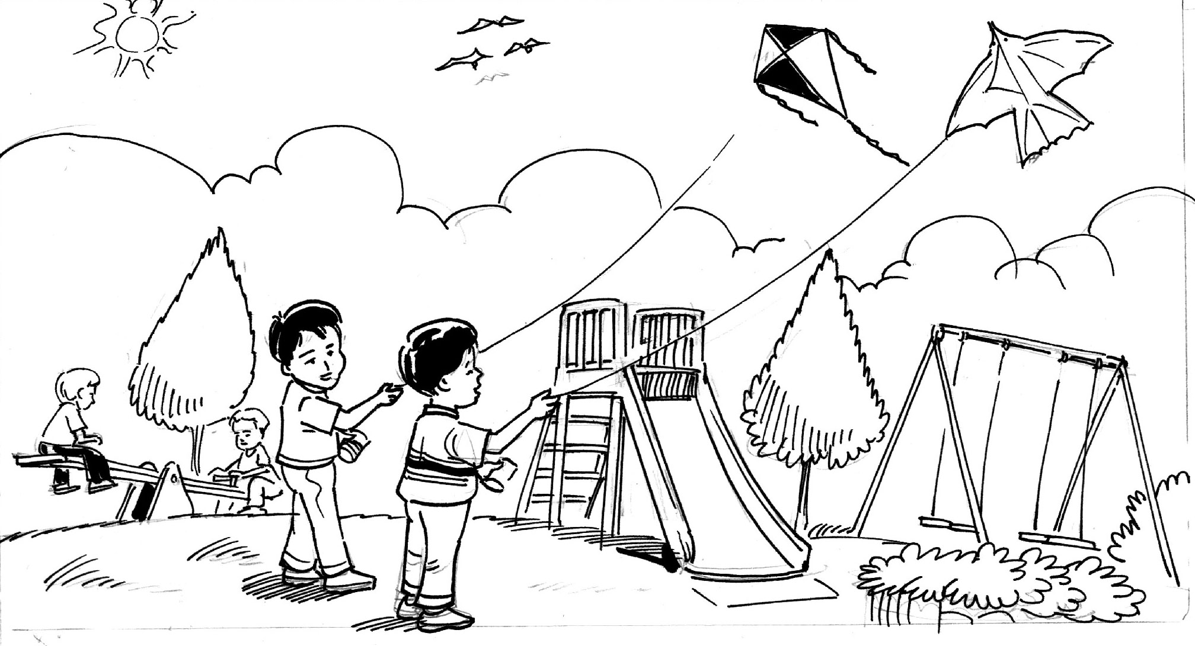
1
2
3
4

playground | boys | kites | play | seesaw
swing | slide | birds | on | sky

Subject/  Nouns | Verbs /  Verb-to-be | Story
this | is | playground
two boys | fly | kites
another two boys | play | seesaw
there | are | swing and slide
three birds | fly | sky

Join the words to construct sentences grammatically correct.

- __________________________________________________

__________________________________________________

- __________________________________________________

__________________________________________________

- __________________________________________________

__________________________________________________

- __________________________________________________

__________________________________________________

- __________________________________________________

__________________________________________________

ENRICHMENT ACTIVITY:
Add other words to construct compound sentences:

- –near a town
- – high – sky - happily
- – siblings - together
- – at the playground
- – sunny day

Rewrite the sentences:

1. ____________________________________________________

____________________________________________________

2. ____________________________________________________

____________________________________________________

3. ____________________________________________________

____________________________________________________

4. ____________________________________________________

____________________________________________________

5. ____________________________________________________

____________________________________________________

TITLE : AT THE CANTEEN
Look at the pictures carefully and write down the nouns and verbs related to th pictures.
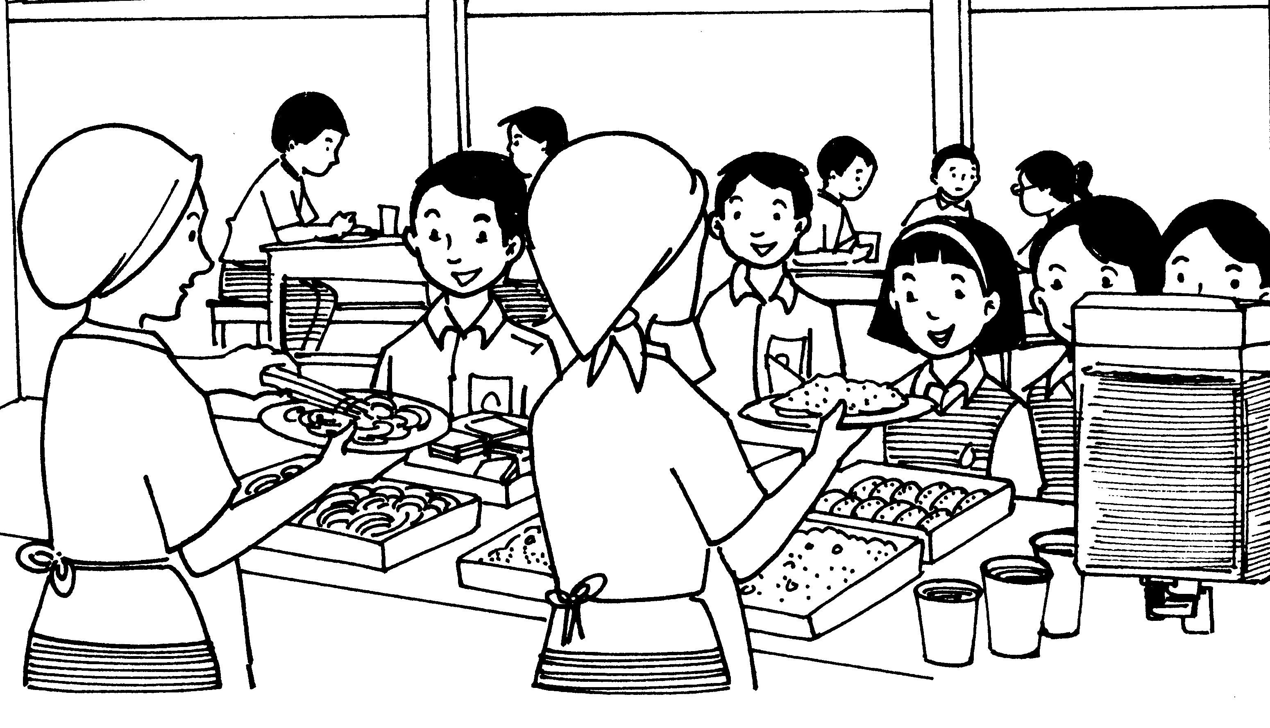
4

2/3
2/3

5

1

recess | queue | counter | boys | girls
buy | food | sit | bench | sell

Subject/  Nouns | Verbs /  Verb-to-be | Story
pupils | are | recess
they | queue | counter
boys and girls | buy | food
they | sit | bench
two women | sell | food

Join the words to construct sentences grammatically correct.

- __________________________________________________

__________________________________________________

- __________________________________________________

__________________________________________________

- __________________________________________________

__________________________________________________

- __________________________________________________

__________________________________________________

- __________________________________________________

__________________________________________________

ENRICHMENT ACTIVITY:
Add other words to construct compound sentences:

- – the canteen
- – silently - buy – favourite food
- – pay - women
- – enjoy – food - happily
- – such – fried rice - noodles

Rewrite the sentences:

1. ____________________________________________________

____________________________________________________

2. ____________________________________________________

____________________________________________________

3. ____________________________________________________

____________________________________________________

4. ____________________________________________________

____________________________________________________

5. ____________________________________________________

____________________________________________________

PAPER 2

SECTION B

TRANSFER INFORMATION

FOR QUESTION 2(B):

GENERAL COMMENTS

Place | - It is a popular place.  - I have never been there before.  - I always want to go there.  - The garden is spacious.  - The building is air-conditioned.  - It has a large compound.
Food | - I have never tried it before.  - It looks delicious.  - The food is more appetizing.  - Th dishes are mouth-watering.
Film | - It sounds interesting.  - I have never seen it before.
Things | - I have never been had it before.  - I always want to have it.  - This bag is more durable compared to the others.  - The black pair of jeans looks more attractive than the blue pair.  - It is of high quality.  - The shoes are ideal for jogging.
People / friend | - I always want a friend from ______.  - I can learn about his/her place through him/her.
Pets | - It looks cute.  - I have never had a ______ as a pet.  - I always want a ______ as my pet.
Competition | - I always want to enter this competeition to show off my talent.
Transportation | - I like to travel in a _______.  - It looks comfortable.
Books/ magazines/ movies | - The magazine is exciting.  - The articles in the magazine are interesting.  - The pictures are colourful.  - It has more pages.  - The movie is action-packed.  - The book is highly recommended for primary school students.
Prices | - The shoes are affordable.  - The price is reasinable.  - It is a good bargain.  - There are attractive discounts.
Activities | - The activities are fun/ challenging.  - Many interesting indoor activities have been lined up.

SUPPORTING STATEMENTS

DETAILS | REASONS | SUPPORTING REASONS
Cost / price | - It costs RM_____.  - They cost RM______. | - It is cheaper than the ________.  - They are cheaper than the _____.  - It is the most expensive but I have enough money to buy it/ My father can buy it for me.  I will save RM____ when I buy the _____ and not the____.  It is within my budget.
Fare / fee | - Its fare/fee is RM____. | - It is cheaper than the ________.  - It is RM_____ cheaper than the ______.  I will save RM____ when I go to the _____ and not the _____.
Food | - It serves _______.  - It has ________. | - _________ is my favourite dish.  - _________ look delicious.  - The food is more appetizing compare to ______.  - The dessert is really fruity and delicious.  - The menu is varied.  - The dishes are mouth-watering.
Offer/  Free gift | - I will get a ______ if I buy it.  - It gives _______ for free. | - I can give it to my _______ for his/her birthday present.  - I will save my money because I do not have to buy it anymore.
Place  (things sold) | - I can get it from the ________.  - It is sold at the ________. | - One of the store is near my house.  - It is near my uncle’s/brother’s house.  I can cycle there.  I can visit my _____ after I had bought the _____.
Place  (situated) | - It is at _______.  - It is held at ________. | - It is near my _______’s house.  - I can walk/ cycle/ take a bus there.  I can visit my _____ after ________.  I can visit ineresting places in _______.
Offer  (discount) | - It offers _____% discount. | - I will pay less after the discount.  - It sounds attractive.  I can save my money.
Colour | - It comes in ______ colours. They are ______.  - It is available in _______. | - I would choose _______ because it is my favourite colour.  - ____ is my father/ mother’s favourite colour.
Facilities | - It has ________.  - The facilities are ______. | Swimming pool:  - I like swimming because it is my hobby.  Moreover swimming is good for my health.  Shopping complex:  - My family and I can o shopping when we want to buy some things.  - I like to go shopping and so is my mother so we can spend our time together shopping.  We will have a good time shopping together.  Tennis court:  - I always want to learn to play tennis.  - I can learn how to play tennis.  - Playing tennis is a good hobby and it is good for my health.  Besides I can make new friends through sports.  Gymnasium:  - I ike to exercise in the gymnasium because exercise is good for my health.  - I like to try the new execise machine in the gymnasium.  Besides exercise will keep me fit and healthy.  Badminton court:  - My brother and I can play badminton in the evening.  - My brother and I can spend our evenings playing badminton at the badminton court.  We can enjoy playing ourselves playing badminton.
Beach | - The ______ is near the beach. | - My family and I can have a picnic on the beach by the sea.  - My family and I ca go swimming at the sea when we have a picnic by the sea.  We will have a good time at the beach.
Offer  (food) | - The ______ gives free breakfast/ lunch/ dinner for ______. | - My brother and I will get free ______.  - My brother/ sister and I will not have to pay for the _____ because it is served free.  My parents will spend less money on food because _____ is served free for _______.
Time | - It starts at _______.  - It is at __________. | - I am free the as I do not have extra classes/ tuition classes/ tuition to attend.
Time  (date  of  competition) | - It is in ______.  - The competition is in _______.  .  . | - I will have a lot of time to prepare myself for the competition.  I will train very hard for the competition.
Product  (locally) | - It is made in Malaysia. | - I like local products. They are cheaper.  Besides we must support local products.
Product  (imported) | - It is made in _____. | - Imported products is well-known for its good qualities.  I will get a good quality product when I buy imported product.
Salary | - It pays RM_______ | - I will get RM____ as my salary when I work for _____ and not the ____.  I can spend and save more with the extra money I get from the salary.
Material | - It is made from _______. | - It is strong and lasts longer.  - It is of high quality.  I can use it for a longer time.
Contents | - It contains _____.  - Its contents is ______.  - It has _______. | - It is _______ more than the _____.
Model | - It is a ____ model. | - It is quite new.  - It brand new.
Prize | - I will get ________ if I win. | Money:  - I can keep the money in the bank.  - I can spend the money on ______.  Things:  - I can give it to my _____ as his/ her birthday present.  - I can share it with my _____.
Age  (competition) | - The contestants/ participants must be ___ years old. | - I am ____ years old so I can participate/ take part in the competition.
Sex | - He is boy/ She is a girl. | - I like to have a friend who is a boy/ girl.
State/ Country | - He/ She is from _____. | - I always want to know about _____.  - I can learn about his/ her about country through him/ her.
Type of film | - It is a comedy/ horror/ adventure/ spy film. | - It is my favourite type of film.
Story line  (film/ books) | - It is about ____. | - It sounds interesting.
Entertainment | - It has _____ for entertainment. | - It is my favourite form of entertainment.
Special features | - It has ____. | - It is _____.
Author | - It is written by _____. | - He/ She is a popular author.  Moreover he/ she is my favourite author.
Availability  (can get from) | - I can get it from _______. | - One of it is near my house.  - It is not far from my house.  I can go there easily on my bicycle with my friends.
Hobbies | - His hobby/ hobbies is/ are ______.  - He likes _____. | - I like _______ too.  We can exchange ideas on _____.  We can play/ talk about _____.
Actor/ Actress | - The actor/ actress is/ are _____.  - The film is starred by ______. | - He/ She is my favourite actor/ actress.  I like to watch his/ he character in any film he/ she starred.
Contact | - I must contact/ ca// _______. | - ______ is my neighbour/ teacher.  I can see him/ her tomorrow.
Ingredients | - The ingredients are _____. | - I can easily get the ingredients from my mother’s kitchen.  - The ingredients are cheap and can be easily bought from the store near my house.  I can learn how to cook and my mother can help me.
Activities | - The activities are ____________ | - The activities are fun/ challenging/ interesting compare to ______ which are boring/ monotonous.  - Most of the activities are indoor/ outdoor activities.  - Many interesting activities have been lined up.
Places  (houses, buildings) | - It has ________ | - The garden is spacious compare to ____ which looks crammed and dirty.  - The building is air-conditioned.  - It has a large compound.

EXERCISE 1
Study the advertisement below carefully. Then complete the table using the information given in the advertisement.

Shoes A  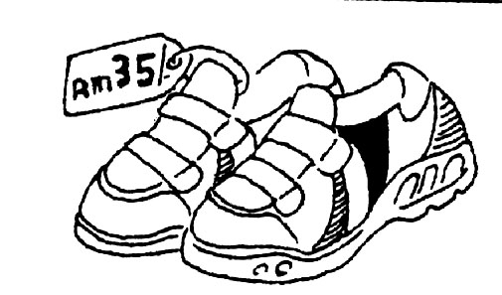 | Shoes B  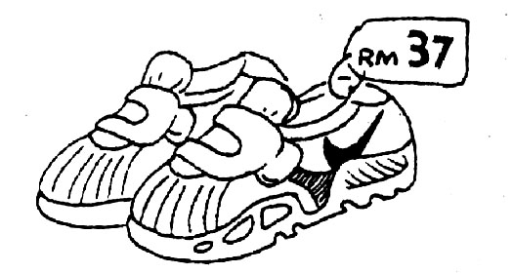 | Shoes C  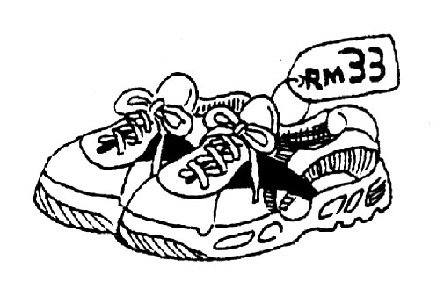
- Made from canvas  - Available at all Champion shoe shops  - Black, white, blue  - A free T-shirt | - Made from canvas and cloth  - Available at all shoe shops  - Yellow, red, green, black  - A free pair of socks | - Made from canvas and rubber  - Available only at leading shoe shops  - White only  - Free book on health

A Complete the table below based on the advertisement given.

 | Shoes A | Shoes B | Shoes C
Material | Canvas | 4. | 7.
Colours | 1. | Yellow, red, green, black | 8.
Available at | Champion shoe shops | 5. | 9.
Price | 2. | 6. | RM33
Free gift | 3. | A pair of socks | 10.

REMEDIAL ACTIVITY:
Fill in the table with your choice. Then join the sentences (reasons) to form a paragraph.

DETAILS | REASONS
choice | I would choose Shoes ______ because I like it very much.
Material | It is made from _______.
Colours | It is available in _______.
Available at | I can get it from _______.
Price | It costs RM_____.
Free gift | I will get a ______ if I buy it.

B. You want to buy a pair of shoes. Which would you choose? Give reasons for your choice.

I would choose ___________ because I like it very much. It is made from

_______. It is available in _______. I can get it from _______. It costs

RM_____. I will get a ______ if I buy it.

ENRICHMENT ACTIVITY:

Fill in the table with your choice. Then join the sentences (reasons and supporting reasons) to form a paragraph.

DETAILS | REASONS | SUPPORTING REASONS
choice | I would choose Shoes ______ | because the shoes are ideal for jogging.
Material | It is made from _______. | It is of high quality.
Colours | It is available in _______. | I would choose _______ because it is my favourite colour.
Available at | I can get it from _______. | It is not far from my house.  I can go there easily on my bicycle with my friends.
Price | It costs RM_____. | It is cheaper than _____.  I will save RM____ when I buy _____ and not ____.
Free gift | I will get a ______ if I buy it. | I will save my money because I do not have to buy it anymore.

B. You want to buy a pair of shoes. Which would you choose? Give reasons for your choice.

I would choose ___________ because the shoes are ideal for jogging. It is

made from _______. It is of high quality. It is available in _______. I

would choose _______ because it is my favourite colour. I can get it from

_______. It is not far from my house. I can go there easily on my bicycle

with my friends. I can get it from _______. It is not far from my house.

I can go there easily on my bicycle with my friends. It costs RM_____. It is

cheaper than _____. I will save RM____ when I buy _____ and not ____.

I will get a ______ if I buy it. I will get a ______ if I buy it. I will save my

money because I do not have to buy it anymore. Based on the reasons, I

think I have made a right choice.

EXERCISE 2
Study the advertisement below carefully.

READING  - indoor activity  - reading materials  - low cost  - library  - increase vocabulary | STAMP COLLECTING  - indoor activity  - stamps, albums  - low cost  - home  - learn more about the countries | FISHING  - outdoor activity  - fishing rods, baits  - high cost  - rivers  - relaxing

A. Complete the table.

 | Reading | Stamp collecting | Fishing
Type of activity | 1. | indoor | 7.
Things needed | 2. | 5. | fishing rods, bait
Cost | low | 6. | 8.
Place | 3. | home | 9.
Advantage | 4. | learn more about the  countries | 10.

REMEDIAL ACTIVITY:
Fill in the table with your choice. Then join the sentences (reasons) to form a paragraph.

DETAILS | REASONS
Choice | I would choose _________ because I like it very much.
Type of activity | It is an ___________ activities.
Things needed | I only need _____________________.
Cost | It needs a _____ cost.
Place | I can _____ at _______.
Advantage | It will ________.

B. Which hobby would you choose? Give reasons for your choice.

I would choose ___________ because _______________________

_________________________________________________________

_________________________________________________________

_________________________________________________________

_________________________________________________________

_________________________________________________________

ENRICHMENT ACTIVITY:

Fill in the table with your choice. Then join the sentences (reasons and supporting reasons) to form a paragraph.

DETAILS | REASONS | SUPPORTING REASONS
Choice | I would choose _________. | because ________________
Type of activity | It is an ___________ activities.
Things needed | I only need _____________________.
Cost | It needs a _____ cost.
Place | I can _____ at _______.
Advantage | It will ________.

B. Which hobby would you choose? Give reasons for your choice.

I would choose ___________ because _______________________

_________________________________________________________

_________________________________________________________

_________________________________________________________

_________________________________________________________

_________________________________________________________

_________________________________________________________

_________________________________________________________

_________________________________________________________

_________________________________________________________

_________________________________________________________

_________________________________________________________

_________________________________________________________

_________________________________________________________

_________________________________________________________

_________________________________________________________

_________________________________________________________

_________________________________________________________

EXERCISE 3

Study the advertisement below carefully. Then complete the table using the information given in the advertisement.

FISH AND CHIPS
fried tuna fish sticks and friescomes with vegetable salad and a soft drinkRM5.50available from
10.00 a.m. – 10.00 p.m.

BEEF BURGER
beef patty, cheese, cucumber and tomato comes with a packet of fries and a soft drinkRM4.50available from 11.00 a.m. – 10.00 p.m.

FRIED CHICKEN
fried chicken drumstick and cucumber saladcomes with mashed potatoes and a soft drinkRM4.00available from 11.00 a.m. – 10.00 p.m.

A Complete the table below based on the advertisement given.

 | Beef Burger | Fried Chicken | Fish and Chips
Type of Meat | Beef | 5. | 7.
Side Dish | 1. | Mashed potato | 8.
Free Drink | 2. | 6. | Soft drink
Price | 3. | RM4.50 | 9.
Time Available | 4. | 11.00 a.m. – 10.00 p.m. | 10.

REMEDIAL ACTIVITY:
Fill in the table with your choice. Then join the sentences (reasons) to form a paragraph.

DETAILS | REASONS
Choice | I would choose _________ because I like it very much.

Type of Meat
Side Dish
Free Drink
Price
Time Available

B You and your sister are going for lunch. Which meal would you choose? Give reasons for your choice.

I would choose ___________ because _______________________

_________________________________________________________

_________________________________________________________

_________________________________________________________

_________________________________________________________

_________________________________________________________

ENRICHMENT ACTIVITY:

Fill in the table with your choice. Then join the sentences (reasons and supporting reasons) to form a paragraph.

DETAILS | REASONS | SUPPORTING REASONS
Choice | I would choose _________. | because ________________

Type of Meat
Side Dish
Free Drink
Price
Time Available

B You and your sister are going for lunch. Which meal would you choose? Give reasons for your choice.

I would choose ___________ because _______________________

_________________________________________________________

_________________________________________________________

_________________________________________________________

_________________________________________________________

_________________________________________________________

_________________________________________________________

_________________________________________________________

_________________________________________________________

_________________________________________________________

________________________________________________________

________________________________________________________

________________________________________________________

________________________________________________________

________________________________________________________

________________________________________________________

EXERCISE 4

Read the notice below carefully. Then complete the table using the information given.

Bahasa Melayu Society

Monday
2.00p.m. -4.00p.m.
Computer Lab
Puan Faridah
Speech training, competition and quizzes
creative

English Society

Tuesday
2.30 p.m. – 4.30 p.m.
School hall
Mrs Chan
jigsaw puzzles and annual excursion
adventurous and creative

Mathematics & Science Society

Wednesday
3.00p.m.-5.00p.m.
Science Lab
Mr Ravi
puzzles, outings and treasure hunts
innovative

A. Complete the table based on the information given.

 | Bahasa Melayu Society | English Society | Mathematics & Science Society
Time / Day | Monday  2.00p.m. -4.00p.m. | 4. | 7.
Venue | 1. | School Hall | 8.
Activities | Speech training,  competitions and  quizzes | 5. | 9.
Teacher-in-charge | 2. | 6. | Mr Ravi
Skills learnt | 3. | Adventurous and  creative | 10.

REMEDIAL ACTIVITY:
Fill in the table with your choice. Then join the sentences (reasons) to form a paragraph.

DETAILS | REASONS
Choice | I would choose _________ because I like it very much.
Time / Day
Venue
Activities
Teacher-in-charge
Skills learnt

B. You want to join one of the societies. Which society would you choose?
Give reasons for your choice.

I would choose ___________ because _______________________

_________________________________________________________

_________________________________________________________

_________________________________________________________

_________________________________________________________

_________________________________________________________
ENRICHMENT ACTIVITY:

Fill in the table with your choice. Then join the sentences (reasons and supporting reasons) to form a paragraph.

DETAILS | REASONS | SUPPORTING REASONS
Choice | I would choose _________. | because ________________
Time / Day
Venue
Activities
Teacher-in-charge
Skills learnt

B. You want to join one of the societies. Which society would you choose?
Give reasons for your choice.

I would choose ___________ because _______________________

_________________________________________________________

_________________________________________________________

_________________________________________________________

_________________________________________________________

_________________________________________________________

_________________________________________________________

_________________________________________________________

_________________________________________________________

_________________________________________________________

________________________________________________________

________________________________________________________

________________________________________________________

________________________________________________________

________________________________________________________

________________________________________________________

EXERCISE 5

Study the advertisement below carefully.

Drawing Competition  - Entrance fee – RM5.00  - Date – 20 November 2008  - Venue – The Mall Room 1  - Bring your own colours and mat  - Prize: Cash money   | Essay Writing Competition  - Entrance fee – RM3.00  - Date – 21 November 2008  - Venue – The Mall Room 2  - Bring your own stationery  - Prize: Books  __________________________________________  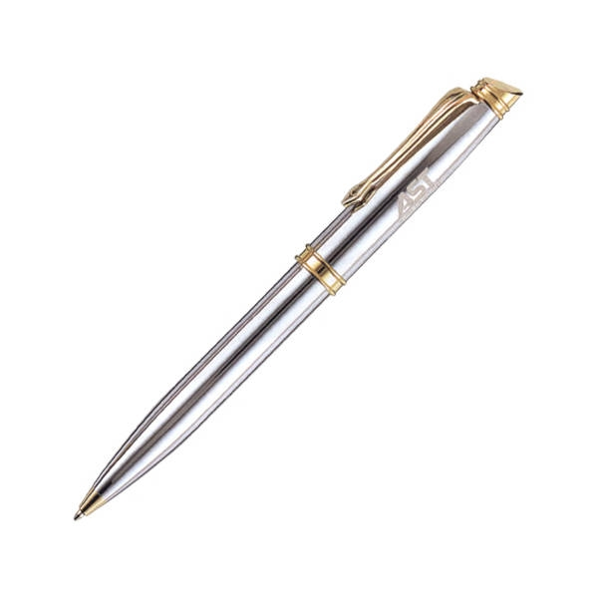

Singing Competition

- Entrance fee – RM 10.00
- Date – 22 November 2008
- Venue – The Mall Lobby
- Bring your own minus one
- Prize: Hampers

A. Complete the table below.

 | Drawing Competition | Essay Writing Competition | Singing  Competition
Entrance fees | 1. | RM3 | 7.
Date | 2. | 21 November 2008 | 8.
Venue | 3. | 5. | The Mall Lobby
Materials need to bring | Colours and mats | 6. | 9.
Prizes | 4. | Books | 10.

REMEDIAL ACTIVITY:
Fill in the table with your choice. Then join the sentences (reasons) to form a paragraph.

DETAILS | REASONS
Choice | I would choose _________ because I like it very much.
Entrance fees
Date
Venue
Materials need to bring
Prizes

B. Which competition would you like to participate? Give reasons for your choice.

I would choose ___________ because _______________________

_________________________________________________________

_________________________________________________________

_________________________________________________________

_________________________________________________________

_________________________________________________________
ENRICHMENT ACTIVITY:

Fill in the table with your choice. Then join the sentences (reasons and supporting reasons) to form a paragraph.

DETAILS | REASONS | SUPPORTING REASONS
Choice | I would choose _________. | because ________________
Entrance fees
Date
Venue
Materials need to bring
Prizes

B. Which competition would you like to participate? Give reasons for your choice.

I would participate ___________ because ________________________

_________________________________________________________

_________________________________________________________

_________________________________________________________

_________________________________________________________

_________________________________________________________

_________________________________________________________

_________________________________________________________

_________________________________________________________

_________________________________________________________

________________________________________________________

________________________________________________________

________________________________________________________

________________________________________________________

________________________________________________________

________________________________________________________

PAPER 2

SECTION A

Note expansion

SIMILES

as happy as a lark | as clear as crystal
as busy as a bee | as greedy as pig
as big as whale | as brave as a lion
as clean as a new pin | as cold as ice
as easy as ABC | as fit as a fiddle
as friendly as a puppy | as hot as fire
as hungry as a wolf | as loud as thunder
as playful as kitten | as proud as a peacock
as quick as lightning | as quiet as a mouse
as sharp as razor | as stubborn as a mule

EXERCISE 1
Look at the pictures. You may use the words given to write about Hasan in the space provided.

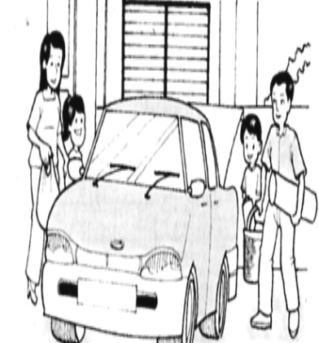
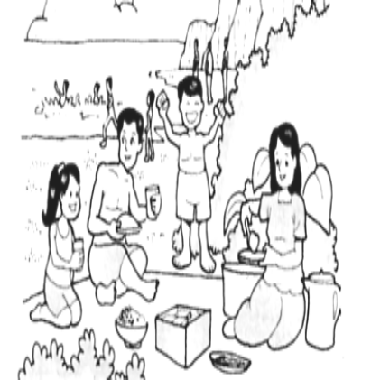

Last Sunday - family – picnic – father – car - morning
arrived – unpacked – prepared – food - ate

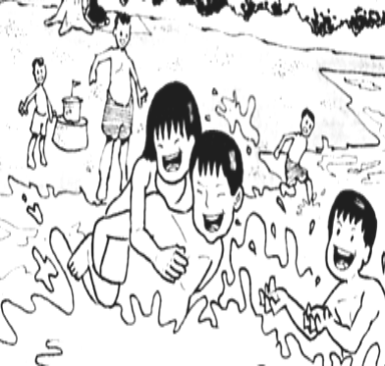

swam – happily – home – tired

Construct sentences based on the words given.

REMEDIAL ACTIVITY
Picture 1
Subject | Verbs | Story
Last Sunday, Hasan and his family | went | for a picnic.
His father | drove | them to Port Dickson.
They | went | there in the morning.

Picture 2
Subject | Verbs | Story
They | arrived | at the seaside.
They | unpacked | their things.
His mother | prepared | some food and they ate together.

Picture 3
Subject | Verbs | Story
They | swam | happily in the sea.
They | went | home in the evening.
They | felt | very tired.

Join the sentences to form paragraphs.

Last Sunday, Hasan and his family went for a picnic. His father drove them to Port Dickson. They went there in the morning.

They arrived at the seaside.They unpacked their things. His mother prepared some food and they ate together.

They swam happily in the sea. They went home in the evening. They felt very tired.
ENRICHMENT ACTIVITY
For more expansion:

- Names the people related in the story: Alimah, En Hashim, Puan Faridah
- Adjectives for nouns: new car, delicious food and drinks, shady tree,
- Adverbs for verbs: safely, happily
- Similes: as clear as crystal, as happy as a lark
- Introduction.
- Closure.
- Moral value.

INTRODUCTION (Paragraph 1)

PICTURE 1 (Paragraph 2)

PICTURE 2 (Paragraph 3)

PICTURE 3 (Paragraph 4)

CLOSURE (Moral Value) (Paragraph 5)

Hasan is 12 years old. He lives in Gombak, Kuala Lumpur with his beloved family. He has a younger sister, Alimah. His father is a teacher and his mother is a housewife. They live happily in a small house.

Last Sunday, Hasan and his family went for a picnic. His father, En Hashim drove them to Port Dickson with their new car. They brought along some delicious food and drinks. They went there in the morning.

After an hour journey, they arrived at the seaside safely.They unpacked their things and put them on the mat. His mother, Puan Faridah prepared some food and they ate together under a shady tree.

Then they swam happily in the sea. The water was as clear as crystal. At about 5.00 o’clock in the evening, they packed all their things and went home. Although they felt very tired, they were as happy as a lark.

It was an enjoyable day for Hasan and his family. He hoped that one day, they will come again to that place.

EXERCISE 2

Look at the pictures. You may use the words given to write about Anuar in the space provided. You are advised to spend about 35 minutes in this question.

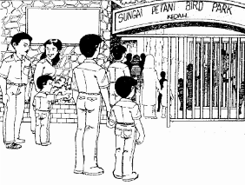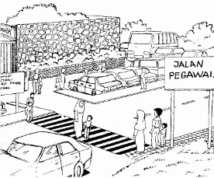
Last weekend – Anuar – parents – famous – bird park – Sungai Petani
situated - Jalan Pegawai – many – came – park - day

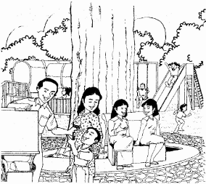
children – playing – bought – ice cream

Construct sentences based on the words given.

REMEDIAL ACTIVITY
Picture 1
Subject | Verbs | Story

Picture 2
Subject | Verbs | Story

Picture 3
Subject | Verbs | Story

Join the sentences to form paragraphs.

_________________________________________________________

_________________________________________________________

_________________________________________________________

_________________________________________________________

_________________________________________________________

_________________________________________________________

_________________________________________________________

ENRICHMENT ACTIVITY
For more expansion:

Names the people related in the story.
- Adjectives for nouns:
- Adverbs for verbs:
- Similes.
- Introduction.
- Closure.
- Moral value.

EXERCISE 3

Look at the pictures. You may use the words given to write about the incident in the space provided. You are advised to spend about 35 minutes in this question.

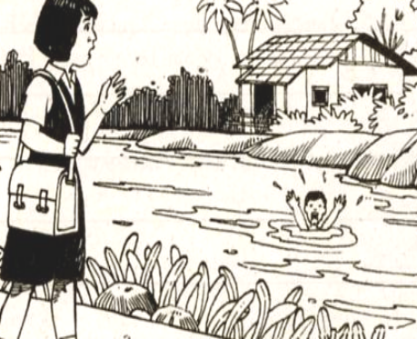
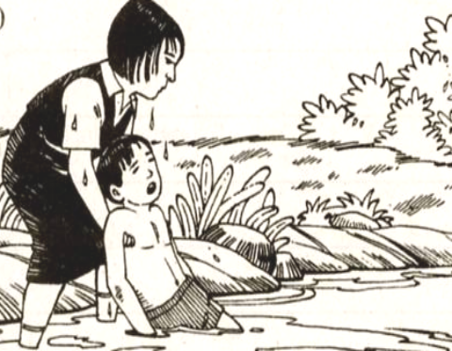

Salma – home – saw – boy -river
Jumped – pulled – river bank - safe

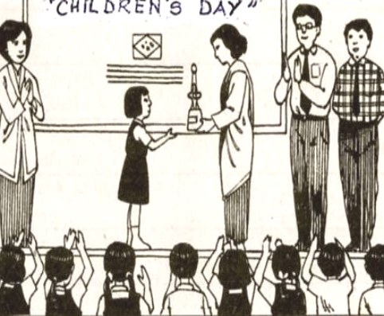

Children’s Day – headmistress – award – brave - proud

Construct sentences based on the words given.

REMEDIAL ACTIVITY
Picture 1
Subject | Verbs | Story

Picture 2
Subject | Verbs | Story

Picture 3
Subject | Verbs | Story

Join the sentences to form paragraphs.

_________________________________________________________

_________________________________________________________

_________________________________________________________

_________________________________________________________

_________________________________________________________

_________________________________________________________

_________________________________________________________

ENRICHMENT ACTIVITY
For more expansion:

- Names the people related in the story.
- Adjectives for nouns.
- Adverbs for verbs.
- Similes.
- Introduction.
- Closure.
- Moral value.

EXERCISE 4

Look at the pictures. Use the information given to write about an incident in the space provided.

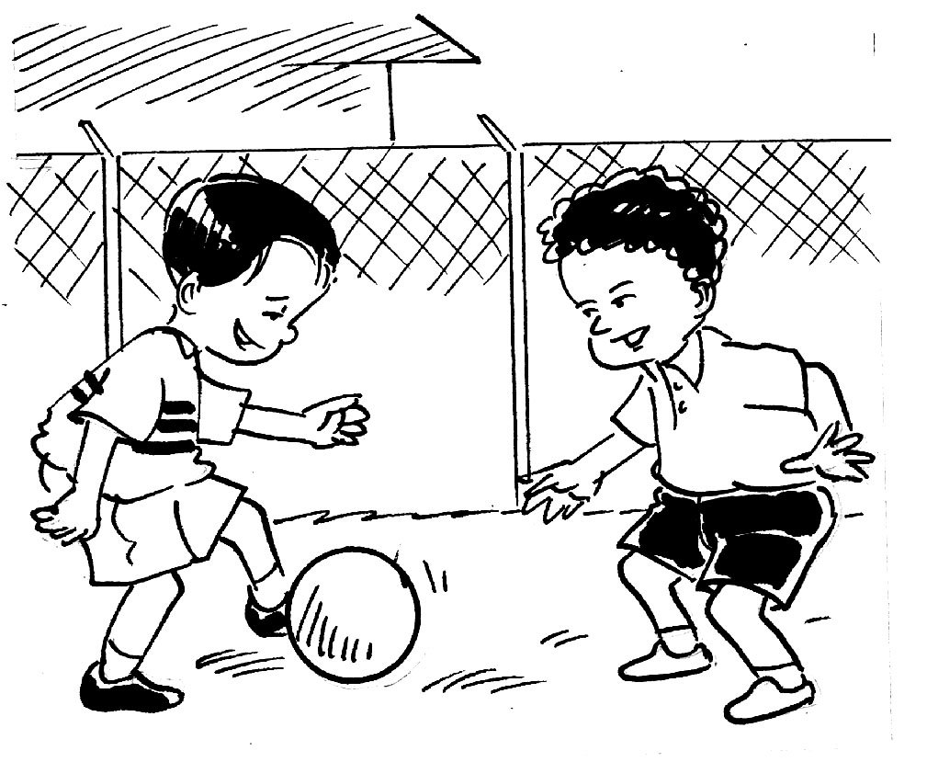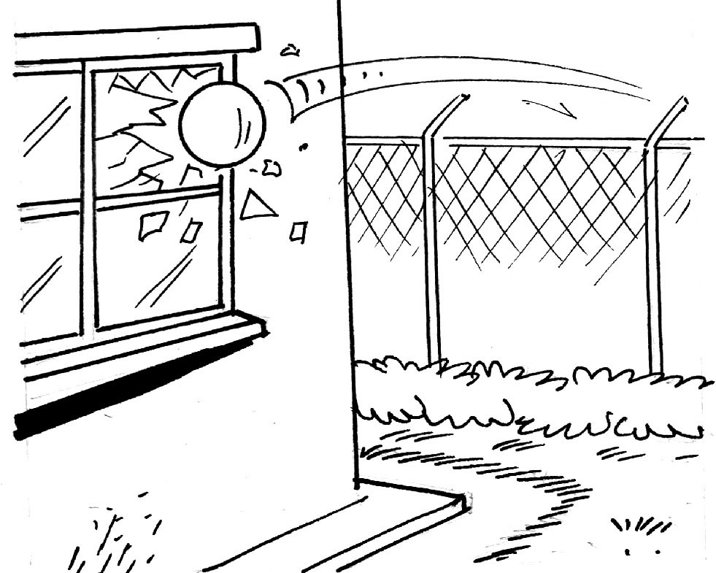
kicked – hard – fence
hit – window – smashed

Mamat – friend – evening – Mamat’s – garden – play football

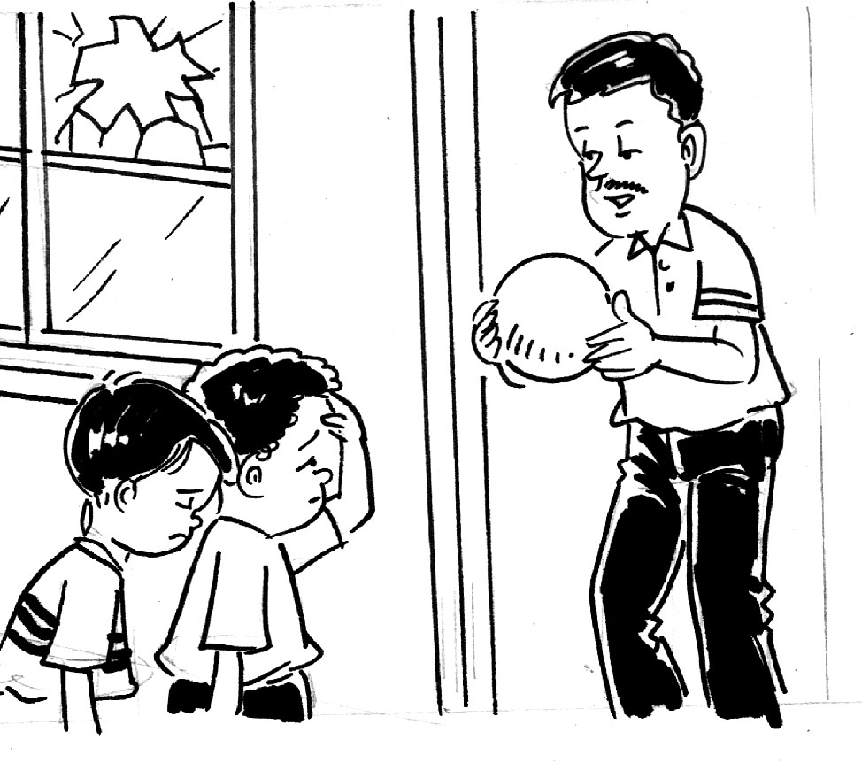
apologised – owner – offered –
pay - promised – careful

Construct sentences based on the words given.

REMEDIAL ACTIVITY
Picture 1
Subject | Verbs | Story

Picture 2
Subject | Verbs | Story

Picture 3
Subject | Verbs | Story

Join the sentences to form paragraphs.

_________________________________________________________

_________________________________________________________

_________________________________________________________

_________________________________________________________

_________________________________________________________

_________________________________________________________

_________________________________________________________

ENRICHMENT ACTIVITY
For more expansion:

- Names the people related in the story.
- Adjectives for nouns.
- Adverbs for verbs.
- Similes.
- Introduction.
- Closure.
- Moral value.

